Details Required for Annual Report preparation
(Details between 01.06.2025 to 31.03.2026)

1. CENTER FOR LEARNING AND TEACHING

1.1 Innovative Teaching Methodologies Followed (Best one per Department)
Department : Aerospace
Course Code & Name:19AST101-Introduction to Aerospace Engineering
Topic : Aircraft Wing Design
Teaching Method : Miniproject

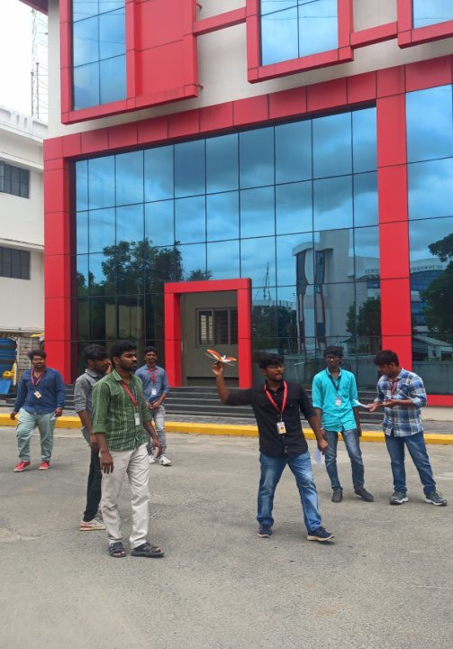
1.2 E-Contents Developed (Faculty & Students)

S.No | Branch | YouTube Lecture videos | Others E Contents
1 | Aerospace | 7 | 8

1.3 Workshops, Seminars, Guest Lectures, FDPs & Course Facilitator Sessions Organized
Workshops Organized

Total Number of workshops Organized: 4
Department : AERO
Workshop Title : One-day workshop on “Drone Photogrammetry”
Date : 11-10-2022
Guest : Mr. T.Abhishek (Founder & CEO, Flyers Drone Tech, Coimbatore)

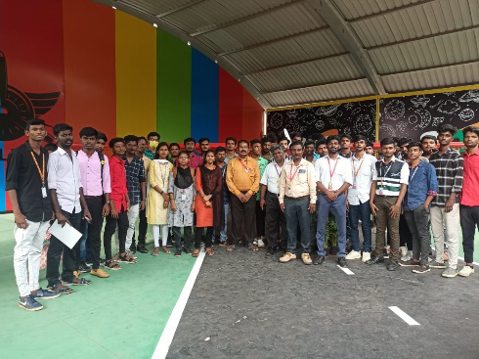

Seminars Organized

Total Number of Seminars Organized: 4
Department : Agricultural Engineering
Seminar Title : All India Seminar on Application of IoT Technologies
Date : 16.03.2023 & 17.03.2023
Chief Guest : Dr.S. Mathivannan, Principal Scientist
ICAR – Indian Agricultural Research Institute - Assam
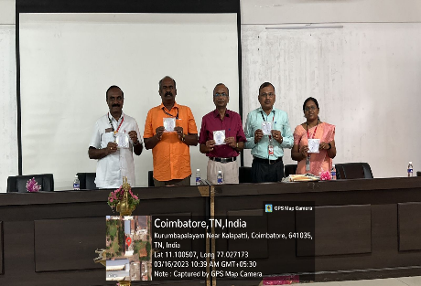
Guest Lectures Organized

Total Number of Guest Lectures Organized: 4
Department : Aerospace & Aeronautical
Guest Lecture Title : Space Mechanics
Date : 21/09/2022
Guest : Prof. R R Elangovan, (Ex. ISRO Scientist), KCG College of Technology, Chennai.
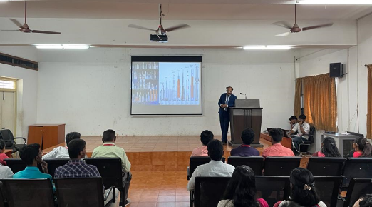
FDPs Organized

Total Number of FDP’s Organized: 4
Department : Aerospace & Aeronautical
FDP Title : Space Mechanics
Date : 21/09/2022 to 26/09/2022
Sponsored Agency : ATAL
Sponsored Amount : Rs.40000
Number of Beneficiary: 30


Course Facilitator Sessions Organized

Total Number of Course Facilitator Session’s Organized: 4
Department : Aerospace & Aeronautical
Course Name : Space Mechanics
Date : 21/09/2022 to 26/09/2022
Course Facilitator Details : Dr.R.Elangovan
Former Senior Scientist, ISRO


1.4 Workshop, Seminar, Guest Lecture, FDP & other technical Sessions Attended by Faculty Members

S.No | Event Type | Attended
1 | Workshop / Hands-on-Training | 12
2 | Seminar | 24
3 | Guest Lecture | 4
4 | Faculty Development Programs | 8
5 | Others | 5

Workshops Attended
S.No | Name of the faculty members | Departments | Title of the workshop  (Online / Offline) | Details of the organizer with place | Date
1 | N.Venkatesh | Aero | 3D printing and additive manufacturing (Online) | Coimbatore Institute of Technology, Coimbatore | 18.2.2026

Seminars Attended
S.No | Name of the faculty members | Departments | Title of the seminar  (Online / Offline) | Details of the organizer with place | Date
1 | N.Venkatesh | Aero | 3D printing and additive manufacturing (Online) | Coimbatore Institute of Technology, Coimbatore | 18.2.2026

Guest Lectures Attended
S.No | Name of the faculty members | Departments | Title of the guest lecture  (Online / Offline) | Details of the organizer with place | Date
1 | N.Venkatesh | Aero | 3D printing and additive manufacturing (Online) | Coimbatore Institute of Technology, Coimbatore | 18.2.2026

FDPs Attended
S.No | Name of the faculty members | Departments | Title of the FDP  (Online / Offline) | Details of the organizer with place | Date
1 | N.Venkatesh | Aero | 3D printing and additive manufacturing (Online) | Coimbatore Institute of Technology, Coimbatore | 18.2.2026

Other Events Attended
S.No | Name of the faculty members | Departments | Title of the event  (Online / Offline) | Date
1 | N.Venkatesh | Aero | Technical Conclave on 3D printing and additive manufacturing (Online) | 18.2.2026

1.5 Workshop, Seminar, Guest Lecture & Course Facilitator Sessions Attended by Students
S.No | Event Type | Attended
1 | Workshop | 12
2 | Seminar | 24
3 | Guest Lectures | 4
4 | Course Facilitator Sessions | 5

Workshops Attended
S.No | Name of the students | Departments | Title of the workshop  (Online / Offline) | Details of the organizer with place | Date
1 | J Aakash | Aero | Composite materials and structures (Online) | PSG Institute of Technology, Coimbatore | 18.2.2026

Seminars Attended
S.No | Name of the students | Departments | Title of the seminar  (Online / Offline) | Details of the organizer with place | Date
1 | J Aakash | Aero | Composite materials and structures (Online) | PSG Institute of Technology, Coimbatore | 18.2.2026

Guest Lectures Attended
S.No | Name of the students | Departments | Title of the guest lecture  (Online / Offline) | Details of the organizer with place | Date
1 | J Aakash | Aero | Composite materials and structures (Online) | PSG Institute of Technology, Coimbatore | 18.2.2026

Course Facilitator Sessions Attended
S.No | Name of the students | Departments | Title of the workshop  (Online / Offline) | Date
1 | J Aakash | Aero | Composite materials and structures (Online) | 18.2.2026

1.6 NPTEL & MOOC Courses (Faculty & Students)

NPTEL/MOOC Courses (Faculty Members)
S.No | Department | Number of courses completed
1 | Aerospace | 24

Details of number of courses completed
S.No | Departments | Name of the faculty members | Platform | Course Name | Duration | Score/ Completed on
1 | Aerospace | Mr.Venkatesh N | NPTEL | Software Testing | 4 weeks | 65 (Elite)/  Feb 2023

NPTEL/MOOC Courses (Students)
S.No | Department | Number of courses completed
1 | Aerospace | 42

Details of number of courses completed
S.No | Class | Name of the Student members | Platform | Course Name | Duration | Score/ Completed on
1 | II Aero | Ajay N | NPTEL | Software Testing | 4 weeks | 65 (Elite)/  Feb 2023

1.7 Academic Achievements
Our students achieved very good results in the End Semester Examinations held in April/May 2025 & Nov/Dec 2025. The Graduation rate of the passed out 2025 batch, in various courses are:
S.No | Branch | Appeared | Graduated | % of Graduation
1 | B.E Aerospace | 19 | 18 | 94.73

Slow learning students in various subjects have been identified and special coaching classes are being conducted to improve their academic performance.

CENTER FOR CREATIVITY
(CFC)

2. CENTER FOR CREATIVITY (CFC)

2.1 Centre with potential for Excellence
- Aerospace Department initiated process to set up a Centre of Excellence in Drone Technology on 27.04.2023. The Resource Person Dr.B.Vinodh Kumar, GM-CDIIC, Codissia Defence Innovation & ATAL Incubation Centre, Coimbatore inaugurated the Centre of Excellence.
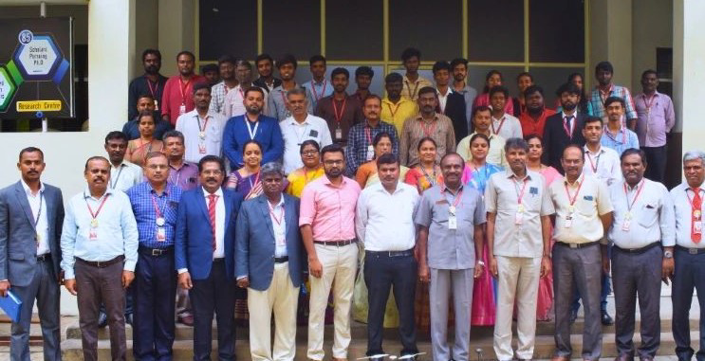

2.2.3 Papers Published in Scopus, WoS & SCIE [Faculty Members]
- M.Subramanian, “The Effect On The Mechanical Properties Of Al₂o₃, Tio₂ Particles Reinforced With Al6063” NeuroQuantology, ISSN 1303-5150, Volume 20, Issue 6, pp. 8853-8861, 2022, IF: 0.453, (Scopus)
2.2.4 Papers Presented in International & National Conferences by Faculty Members
S.No | Event Type | Organized | Attended
1 | International Conferences | 1 | 14
2 | National Conferences | 1 | 7

International Conference Publication [Faculty]
- R.Mohana Priya &R.Muthuminal, Presented a Technical Paper Entitled “ Study on impacts of climate change towards agriculture produce” In International Conference SISTEEM 2022 organized by Bannari Amman Institute of Technology, Sathyamangalam.
National Conference Publication [Faculty]
- R. Muthuminal, “Investigation on Utilization of Industrial waste in Road Construction and it’s Environmental Effects" in the National Conference DigiTechCON'22, organized by Sona College of Technology.

2.2.5 Papers Published in International & National Journals by Students
- Deebaa S and Karthik S“Improving the performance of cloud data center with scheduling and load balancing” International Journal of Applied Engineering Research (IJAER), Volume 10, Number 41 (2015), pp.30563-30566.
2.2.6 Papers Presented in International & National Conferences by Students
- Dhakshina Shree.G of third year Biomedical Engineering has successfully presented a paper titled on Advancement of cost effective vien analyzer for health care applications at the sixth international conference on Electronics, Communication and Aerospace Technology organized by RVS Technical Campus, Coimbatore on 10.02.2023
2.3 Papers Presented in Symposium by Students
- Arul Pandi K & Shankar Harish B of second year Biomedical Engineering presented a paper in National Level technical Symposium held at Kumaraguru College of Technology, Coimbatore on 20.02.2023
2.4 Books/ Book Chapters Published by Faculty Members
- Dr. B. Sivasankari presented a paper titled “Recent Developments in Schottky Diodes and their Applications” published by Taylor & Francis Group in July 2022.
2.5 Patents Filed/ Published & Granted
S.No | Application Number | Date of Grant/ Published/Filed | Name of the faculty members | Title of the Patent | Filed  /Published /Granted | Design/  Product
1 | 95241684258 | 10.02.2026 | Dr. K.Manoharan | Machine learning based approach to study the positive and negative traits of Genome editing technique in Cancer Patients | Published | Product

2.6 Grant’s Received
S. No. | Departments | Description | Granting Agency | Grant Amount Received ₹
 | CIVIL | Grant for Study Tour of ATAL Tunnel under the AICTE Youth Undertaking Visit for Acquiring Knowledge (Yuvak) Scheme | AICTE | 1,00,000

2.5 Fund Generated through Consultancy
S.No | Department | Consultancy to | Revenue Generated (Rs) | Status
1 | MCT | Devi Automation, Coimbatore | 1,53,690 | On going

2.8 Fund Generated through Startups
S. No. | Departments | Name of the startup | Month & Year of Starting | Amount Generated ₹
 | Aero | Aeronet | NoV 2025 | 1,00,000

2.9 Hackathon /Ideathon Organized

Total Number of Hackathons Organized:2
Department : Aerospace
Event Type : Conference
Conference Title : IoT in aerospace
Date : 21/09/2022


Total Number of Ideathons Organized:2
Department : Aerospace
Event Type : Ideathon
Hackathon Theme : IoT in aerospace
Date : 21/09/2022


2.10 Business Model Canvas(BMC) Videos
S.No | Branch | No. of BMC videos Taken
1 | Aerospace | 7

SKILL & CAREER DEVELOPMENT

(SCD)

3. SKILL & CAREER DEVELOPMENT (SCD)
3.3 Students Participation
S.No. | Departments | Type of events | Number of students
1 | Aero | Hackathons / Ideathons Participated | 25
2. | Aero | Technical Events Attended | 11
3. | Aero | Non-Technical Events Attended | 10

3.4 Students Achievements
S.No. | Class | Name of the Studnets | Date of the Event | Name of the event | Organized by | Place
1 | III Aero | Ramanuja Ganesh K  Silambarasan S | 18.10.25 | Bottle Rocketry | VELS Institute of Science and Technology & Advanced studies, Chennai | I
2. | II Aero

3.4 ISTE, IETE & CLUB ACTIVITIES

Total Number of Activity Organized:2
Department : Computer Science and Engineering
Title : Seminar on Cloud Computing platforms
Date : 13.03.2023
Chief Guest : Mr.K.Santhosh Kumar, Social Media Analyst, ATS

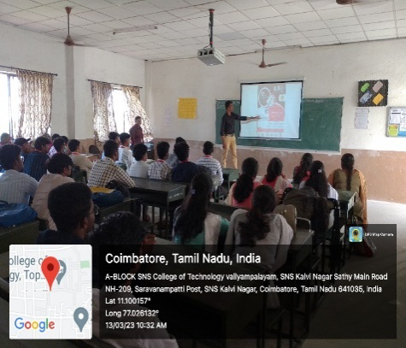

IETE ACTIVITIES

Total Number of IETE Activity Organized:2
Department : Mechanical Engineering
Title : Seminar on Additive Manufacturing
Date : 15.09.2022
Chief Guest : Dr. M. Sabarimalai Manikandan ,
IIT Palghat



Club Activities
Total Number of Club Activity Organized:2
Club Name : Aeromodelling club
Department Name : Aerospace Engineering
Event Title : One-day workshop on
“Drone Photogrammetry”
Date : 11-10-2022
Chief Guest : Mr. T.Abhishek (Founder & CEO, Flyers Drone Tech, Coimbatore)


3.7 Global Certifications
S.No. | Class | Name of Certification | No. of Students Completed
1 | II Aero | Microsoft Azure Fundamentals | 22
2 | II Aero | Data science | 13

INDUSTRY INSTITUTE PARTNERSHIP CELL (IIPC)

4. INDUSTRY INSTITUTE PARTNERSHIP CELL(IIPC)

4.1 Memorandum of Understanding (MoU) Signed
For better Industry Institute Relationship, in addition to the existing 25 MoU’s signed with industries, 3 MoU’s are signed in this year as on date. The Institution avails the following benefits on signing MoUs
  - Industrial visits,
  - In-plant training,
  - Industrial Projects and
  - Delivering guest lecturers mutually

MoUs Signed This Year
Department : Aerospace & Aeronautical
Company : M/s.Aghora Design Academy Pvt Ltd, Coimbatore
MoU Period : 29.09.2022 to 29.09.2027 (Five Years)

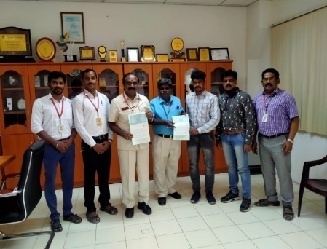

4.2 Industry Collaborated Activities

Sl.No. | Type of events | Student  Count
1 | No. of Inplant Training Attended | 46
2 | No. of Internships undergone | 926
3 | No. of Industries Visited (Industry Count) | 39
4 | No. of Industry Projects Completed | 310

4.2.1 Details of Internship
S.No. | Departments | Name of the Students | Name of the Industry | Internship Category (Paid / Unpaid) | Amount Received
1 | Aero | Arjun M | ISRO | Paid | 10000

4.3 Industrial Visits Organized

Total Number of Industry Visits: 2
Department : Aerospace
Industry Name : ZF Wind Power Private Limited, Coimbatore
Date : 21/09/2022



4.4 Details of Industrial Projects
S.No. | Class | Name of the Students | Name of the Industry with Address | Title of the Project
1 | Aero | Arjun M | ISRO

SOCIAL RESPONSIBILITY INITIATIVES (SRI)

5. SOCIAL RESPONSIBILITY INITIATIVES
5.2 Extension Activities Organized

Total Number of Activities Organized: 25
Department : Aerospace
Title : Tree Plantation
Date : 12.01.2023
Venue : Panchayat Union Office, Agali

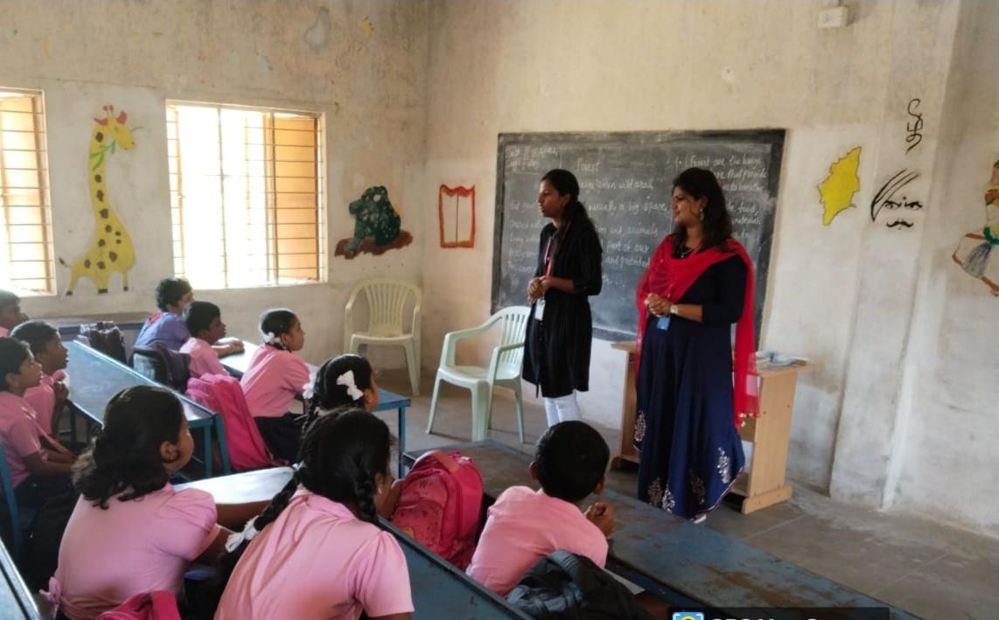

5.2.1 DT Bootcamps Organized

Total Number of Bootcamp Organized: 25
Department : Aerospace
Title : Design Thinking for Educators
Date : 12.01.2023
Venue : Government Higher Secondary School, Madukarai



